**QSMART – LASER ADJUSTMENT**

**PROCEDURE**

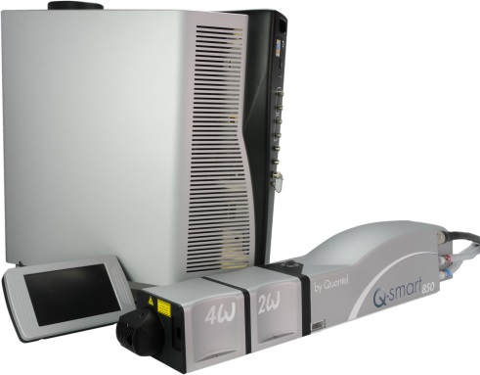

**Toolkit:**

Allen keys

Energy meter

Photodiode

Oscilloscope

**System** : QSMART

|  |  |  |  |
| --- | --- | --- | --- |
|  |  |  |  |
|  |  |  |  |

**Purpose**: This document details how to change align the laser components

|  |  |  |
| --- | --- | --- |
| Revision | date | modification |
| Initial issue | July 4, 2014 |  |
|  |  |  |
|  |  |  |
|  |  |  |

# LASER ADJUSTMENT (Beam analyzer or burn paper)

Tools :

* Energy meter
* Photodiode
* Oscilloscope
* Disconnect Q touch and link the power supply to the PC with Ethernet RJ45 cable
* Launch Qsmart-Service application

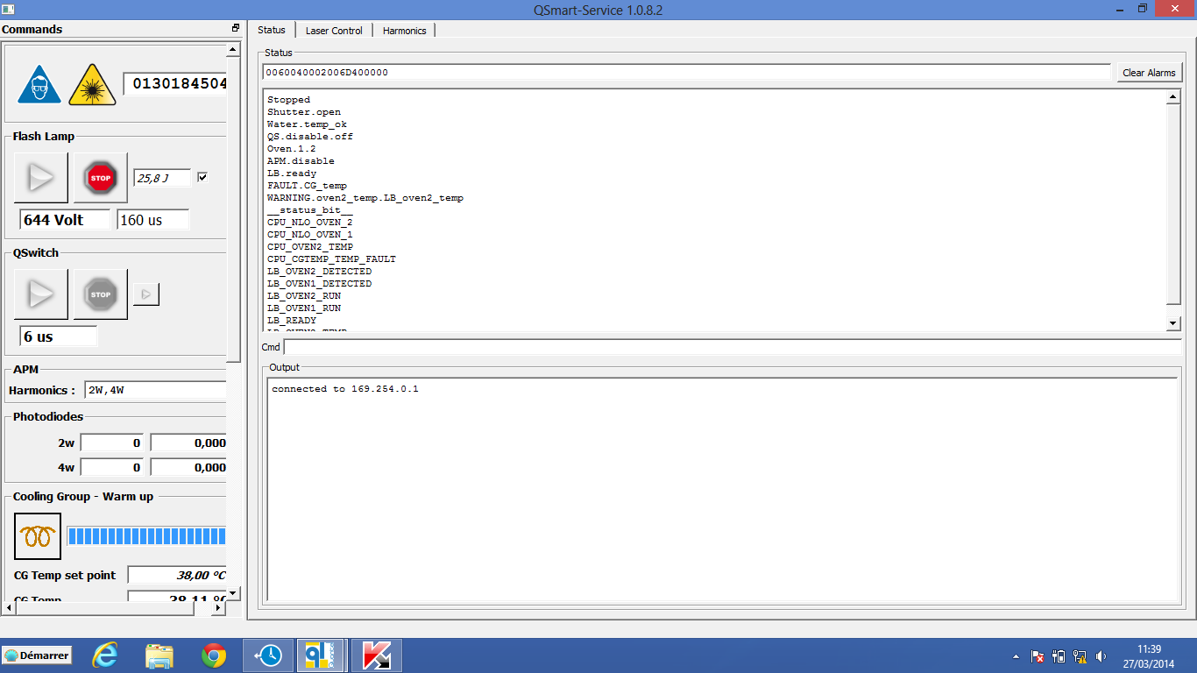

* In case of no PC communication with the laser, enter IP address 169.254.0.10

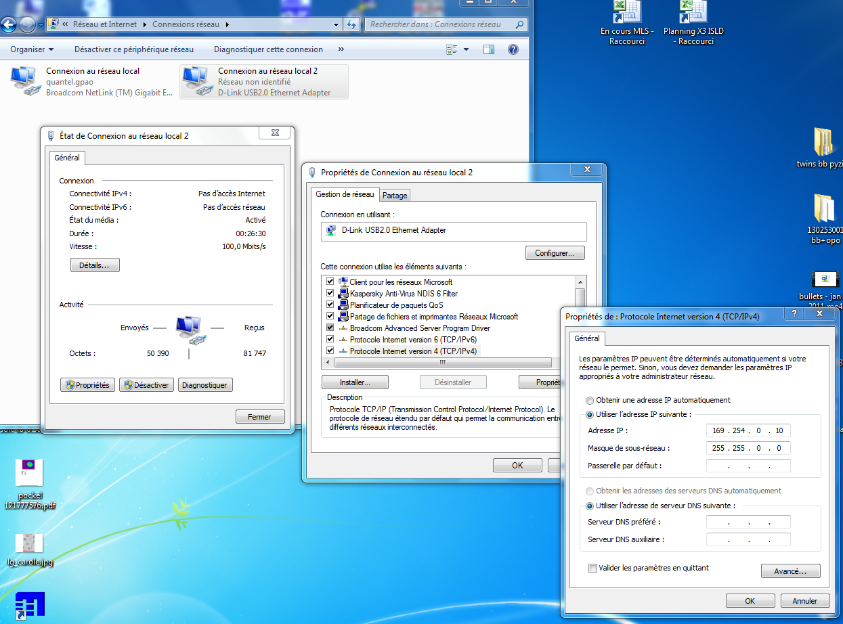

* Open « Modulo.ini » text file et enter port number 169.250.0.1

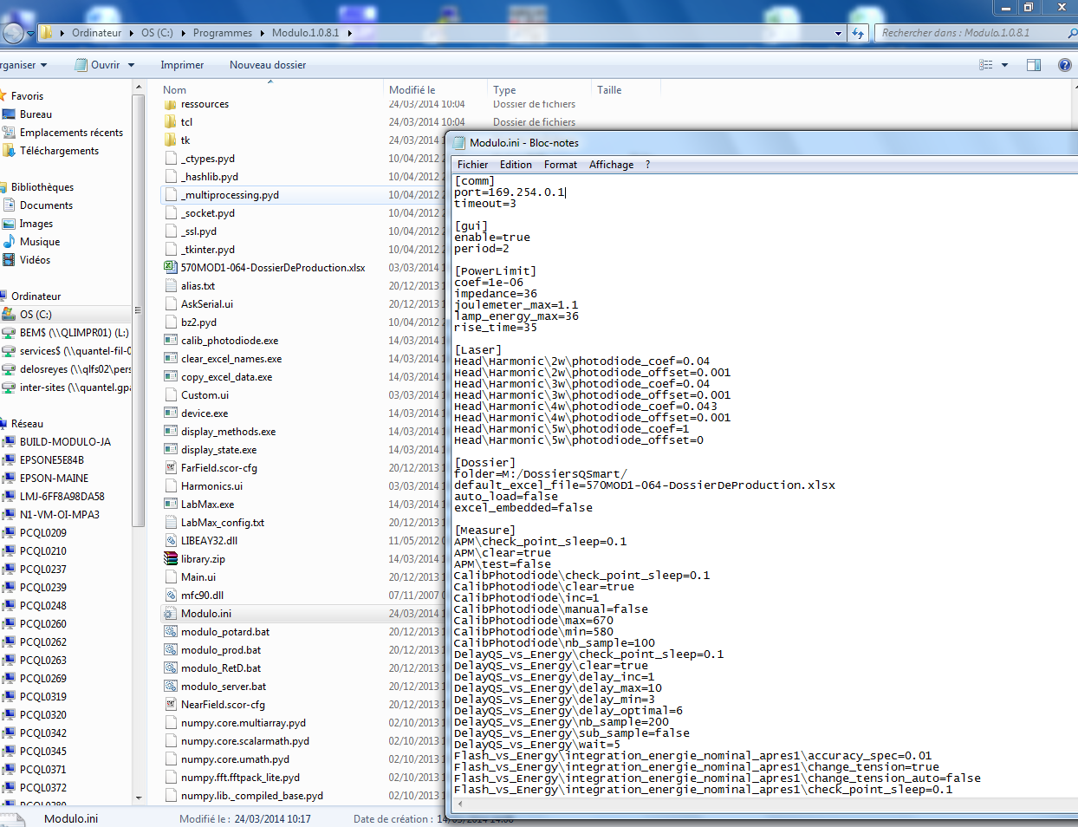

### Remove the quarter wave plate mount (and cylindrical lens if present)

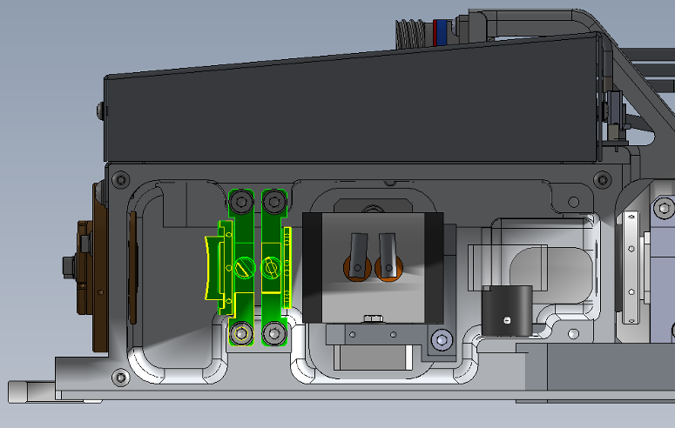

* Check for the following values or status (“Laser Control” sheet) :
  + Lamp Voltage = 600V (Charger Set Point)
  + Pulse Width = 170µs
  + Shutter = Open

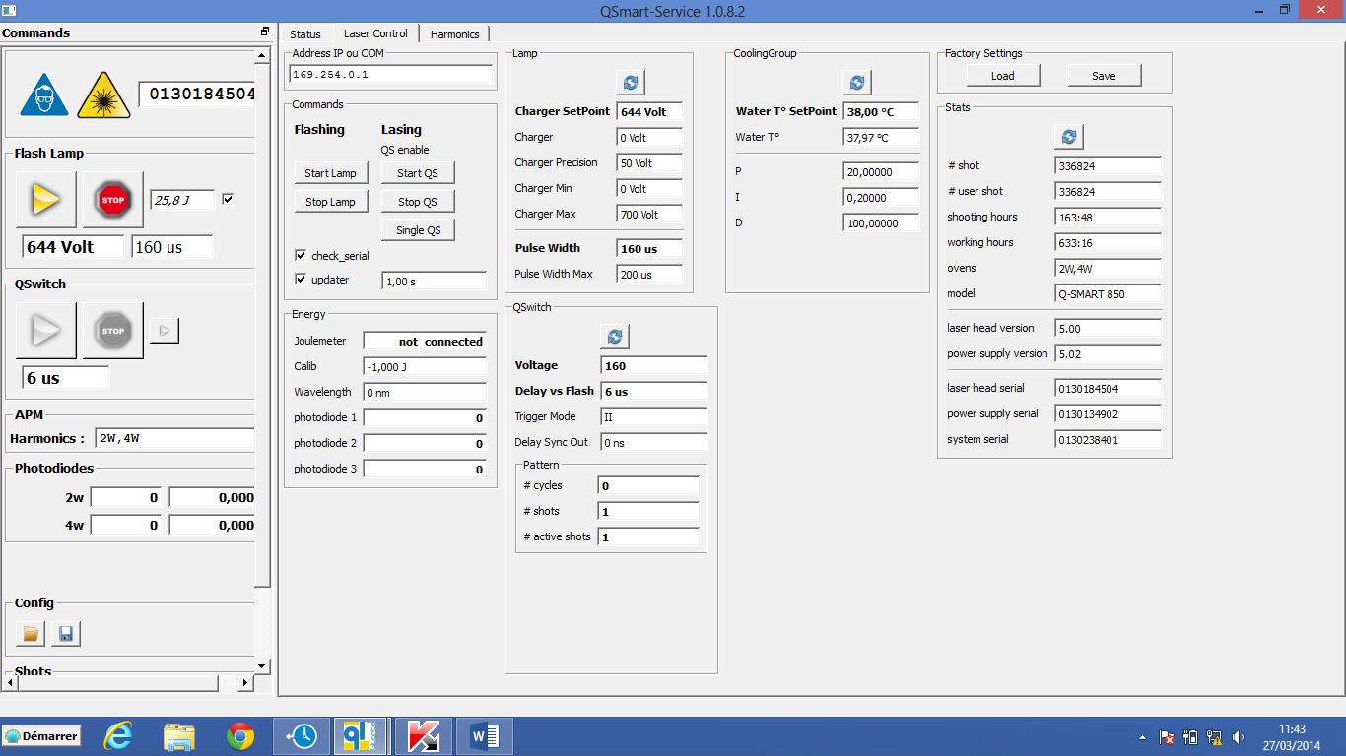

* Fire Flashlamps
* Check for Shutter Led which must be continuously lighted
* Align the back mirror rotating mounts in order to get an image on the beam analyzer screen or on the burn paper.

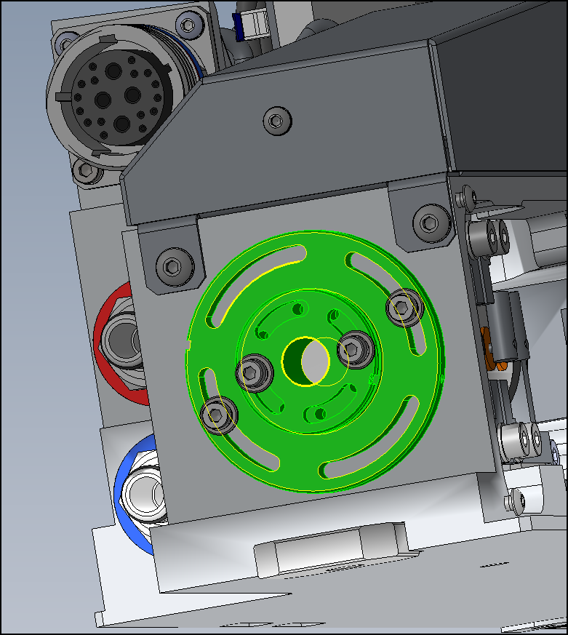

* Optimize the laser pattern roundness
* Maximize the energy by rotating the front quarter wave plate
* Adjust lamp voltage to get 850 mJ energy
* Remove the energy meter and check that the beam pattern is still fine
* Switch the lamps off
* Put back in place the quarter wave plate
* Switch the lamps on
* Check pulses with the photodiode
* Rotate the quarter wave plate in order to stop lasing
* In case of remaining pulse intensity, slightly adjust the Pockels cell alignment to get a complete extinction (first unlock the Pockels cell mechanics)
* Clic on Laser Control Sheet
* Increase the lamp voltage up to 680 V and pulse width up to 180 µs and check again for laser pulse extinction. If not successful, readjust the Pockels cell alignment

Lock the Pockels cell and quarter wave plate mechanics. Check again for extinction.

* Cocher sur « cavité fermée » et cliquer sur « save »

### Enter the following parameters :

* QS voltage = 160
* Qs Delay vs Flash = 7 µs
* Lamp voltage =600 V
* Pulse Width = 170 µs

### Optimize the beam alignment in Q-Switch mode

### Replace the cover plate without fully tightening the screws

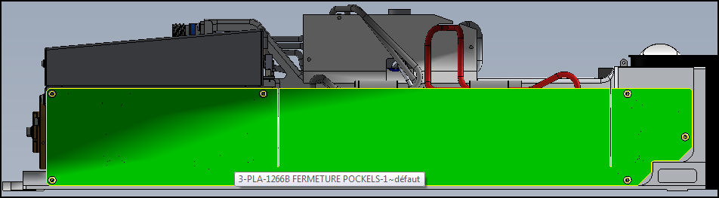

Wait for thermalization of the cover before tightening the screws. (TEMPS ?)

* Tighten the back cavity mirror and check its alignment with the impact paper at 30cm. Re-adjust the back mirror if needed.
* Turn the system off
* Disconnect cables and water hoses on the laser head side
* Replace the laser head cover

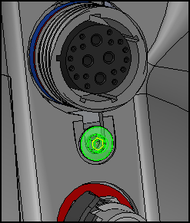

* Connect cables to the laser head
* Adjust lamp voltage to get 850mJ
* Check paper burns at 30cm, 1m et 2m to be confident

# SAVE PARAMETERS

* Save using Cmd = FPGMx2
* Save Excel File

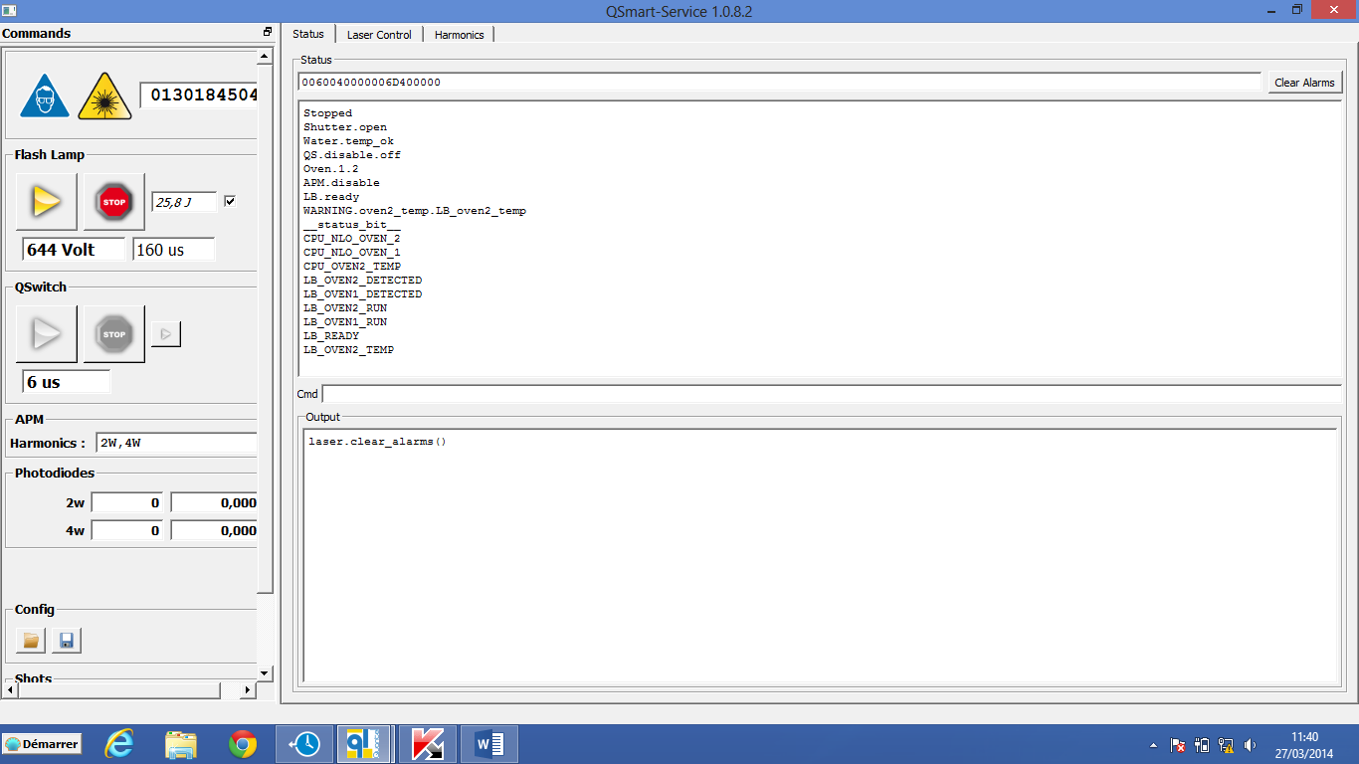

* Switch off and on the Power Supply and check that new parameters are saved.